## Deployment Steps

**Setup Postgres DB Service**

1. Login into [Render Dashboard](https://dashboard.render.com/) . Select **PostgresSQL** from **New** drop down menu.  
     
   A screenshot of a computer

   Description automatically generated
2. Specify
   1. Name of PostgresSQL instance - “**vitality-nector-db**”
   2. Database – **vitalitynectordb**
   3. User – **vn1**
   4. Select nearest region – **Frankfurt(**EU Central)
   5. Make sure Postgres version is **16**
   6. Select Instance Type as **Free**
   7. Click on “**Create Database”** button

1. PostgresSQL service will start in some time. Click on **Connect** drop down menu and from **Internal** tab copy **Internal Database URL**

**Setup Flask Web Service**

1. **Requirement.txt** in github repo (https://github.com/Irenetitor/VitalityNectar) mentions package dependencies needed by render.com

1. In Render.com, after login into dashboard select **Web service** from **New** drop down menu.

1. Select option – Build and deploy from git repository and click next

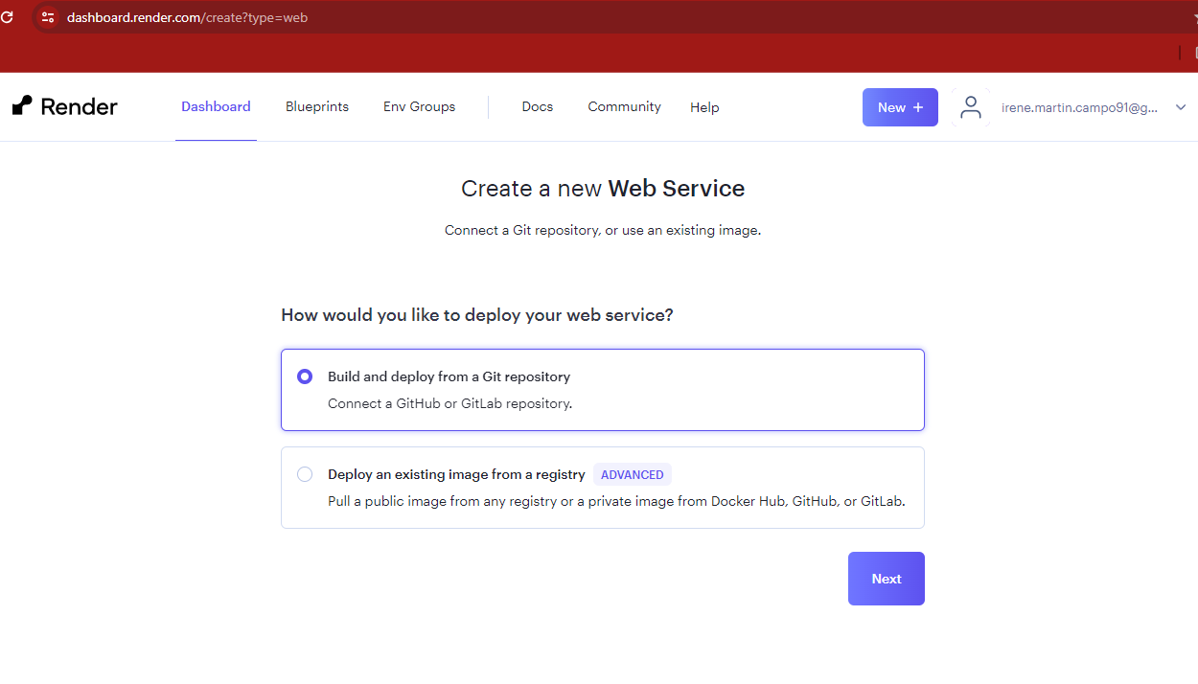

1. **Connect** with gitrepo https://github.com/Irenetitor/VitalityNectar A screenshot of a web service

   Description automatically generated
2. Specify
   1. Name for web service instance – **VitalityNectar**
   2. Select nearest region – **Frankfurt(EU Central)**
   3. Branch for repo as **main**
   4. Keep Runtime as **Python 3**
   5. Build comment as $ **pip install -r requirements .txt**
   6. Start command as $ **gunicorn app:app**
   7. Select Instance Type as **Free**
   8. **IMPORTANT – Mention Environment variable DATABASE_URL as copied Internal Database URL for deployed PostgresSQL service before while setup of PostgresSQL database.**
   9. Click on **Create Web Service** button

1. After web service start is successful. Go to **https://vitalitynectar.onrender.com** to access website

